Engineering Faster Reaction Times

Why are faster reaction times important?
According to the Centers for Disease Control, a government agency that tracks risks to public health, in 2018, over 2,800 people were killed and an estimated 400,000 were injured in crashes involving a distracted driver in the United States. About 1 in 5 of the people who died in crashes involving a distracted driver in 2018 were not in vehicles―they were walking, riding their bikes, or otherwise outside a vehicle. What can scientists, engineers, and policy-makers do to prevent these devastating tragedies?

Reaction time is a major factor in determining whether a situation will become fatal. A longer reaction time means less opportunity to slow down or even stop before a collision. Although ideally a driver will stop the vehicle before a collision occurs, any amount of slow down improves outcomes. A pedestrian who gets hit by a slower moving car is significantly more likely to survive, as in the infographic at right. So what design solutions are being implemented to give drivers as much time as possible to slow down or stop before a collision, potentially saving thousands of lives every year?
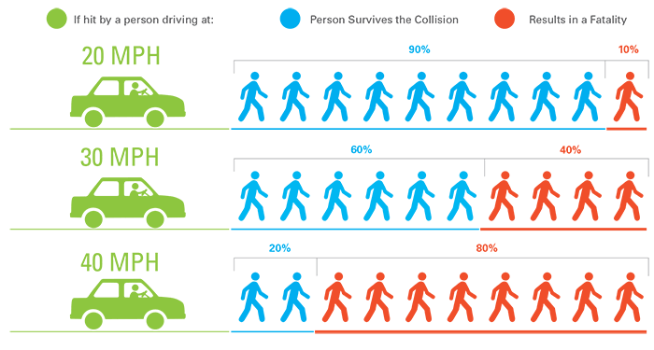

(Engineering solutions like heads up displays on cars and turn-off-notifications settings on phones can also make an impact, but they have constraints (see engineering progress tracker for more takeaways).)

Design Solution 1: Heads Up Displays
Heads-up-display (HUD) technology is one way to prevent distraction, and thus decrease reaction times. This technology was used on United States military aircraft in the early 1960s, and first seen in cars in 1988 when General Motors offered it in the Oldsmobile Cutlass Supreme. Today, this technology is becoming widely available, with more than 30 carmakers offering HUD as an option on one or more of their vehicles. Typically a car with HUD technology will have a projector that displays data that is important to the driver on the vehicle’s windshield, or a retractable panel on the dashboard. The driver can see the data without taking eyes off the road. A heads up display can give the driver information that they might otherwise need to look away from the road to obtain, such as:
- Vehicle speed
- Navigation information
- Musical artist, song and album
- Turn signal on
- Battery charge
- Blind-spot monitoring

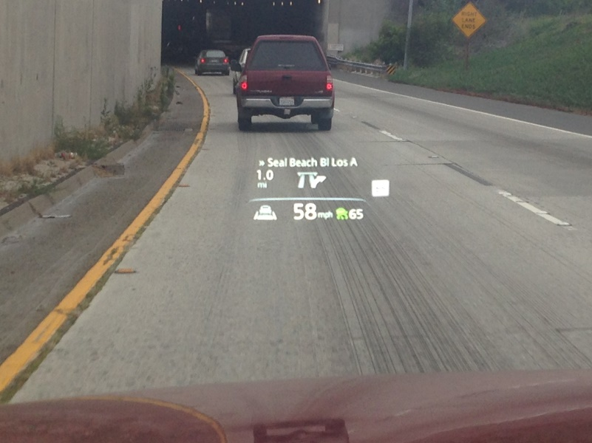

There are major constraints on this type of technology. It’s an expensive option on newer cars, and difficult or impossible to install in older cars. These constraints may affect some people more than others. Because of this, access to this life-saving technology is not equitable right now.

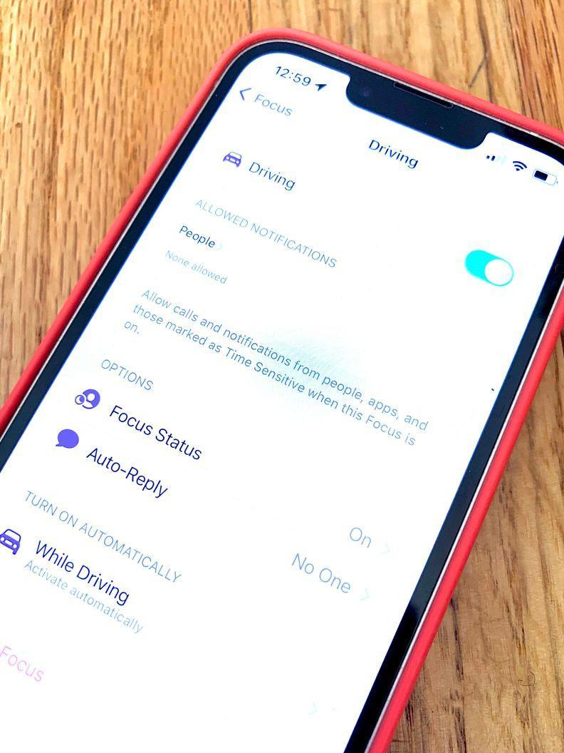
Design Solution 2: Do-Not-Disturb Phone Settings
Increased cell phone use is likely a major factor in the trends we have seen in vehicle collisions over the past decade. According to a 2019 CDC study, 39% of high school student drivers surveyed reported texting or emailed while driving at least once in the previous 30 days. Texting or emailing while driving was more common among older students than younger students and more common among white students (44%) than black (30%) or Hispanic students (35%). Texting or emailing while driving was just as common among students whose grades were mostly As or Bs as among students with mostly Cs, Ds, or Fs.

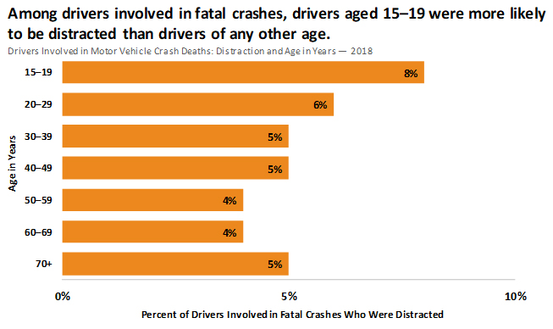

Newer cell phone models offer a feature where drivers can choose to turn certain notifications off while driving, making it less likely that they will be distracted by a new text or social media update. If all drivers turned on this option, it could save thousands of lives. But again, there are major constraints on this type of technology. The technology is not automatic, and requires the driver to opt-in. Some people don’t opt-in, and some people don’t know about the feature. According to the CDC, those drivers who report using their cell phones while driving also report other risky driving behaviors, such as not using a seat belt, so it is less likely that these drivers will choose to utilize the do-not-disturb settings.

Design Solution 3: High-Visibility Enforcement
High-visibility enforcement efforts aim to prevent cell phone use while driving by increasing the perceived risk of getting a ticket. This strategy requires an increased number of officers patrolling specific areas, and advertising campaigns aimed at reducing the use of cell phones. There are major constraints to this strategy as well. First, enforcement relies on human judgment, which can be biased toward or against certain cars or drivers. Second, fines are not a deterrent for drivers who have a lot of money and other resources at their disposal. Both of these constraints taken together suggest that this solution may affect some people differently than others, potentially leading to inequitable outcomes. In addition, according to the CDC, drivers who report using their cell phones while driving also report other risky driving behaviors, such as not using a seat belt, so it is less likely that these drivers will respond to advertisement campaigns.

Design Solution 4: Speed Limits and Cameras
One of the simplest and most effective ways to reduce stopping distances is to convince drivers to slow down. The impact of starting speed on stopping distances (and thus collision risk) is easily explained by kinematics, a branch of physics that deals with the motion of objects, without considering the forces that cause that motion. The time it takes a car to stop can be broken into two periods of time: the reaction time, and the braking time. How far a vehicle travels during the reaction time, known as reaction distance, is going to be determined by the speed the car is traveling, multiplied by the reaction time. How far a vehicle travels during the braking time, known as braking distance, is going to be determined by a number of factors, including the speed the car was going before attempting to stop, the road surface on which the car is driving, and the quality of the brakes in the car. Speed limits may not be able to directly change our reaction times if we are distracted, but they can decrease the distance traveled by a car during that time, giving drivers the space to stop or slow down before a collision.

What constitutes a safe speed for a vehicle depends how much space they will have to stop. Drivers should always follow the car in front of them with at least 3 seconds of following distance in order to provide enough stopping distance. The recommended speed limit is based on many factors, including road conditions, visibility, and public opinion.

Research shows that speed limits work to reduce the number of vehicle collisions. For example, in December 2005, a new speed limit was introduced on Italian motorways. Research using 320 cameras installed across these motorways showed a clear decrease in average speed of vehicles, and a major reduction in the number of crashes. On one central urban motorway, the average speed of cars decreased by 10%, and the number of vehicle collisions decreased by 32%.

One way to enforce speed limits is with speed cameras. But a recent analysis of millions of citations in Chicago found that households in majority Black and Hispanic ZIP codes received tickets at around twice the rate of those in white areas between 2015 and 2019. A local political representative from Chicago, Daniel La Spata, insisted that tickets from speed cameras were still important to reduce speeds and save lives, but that “Black and Latino Chicagoans tend to live in the most car-dependent areas, they tend to live in the communities that have the least complete streets and infrastructure,” and that this means that these communities are unfairly impacted by fines.

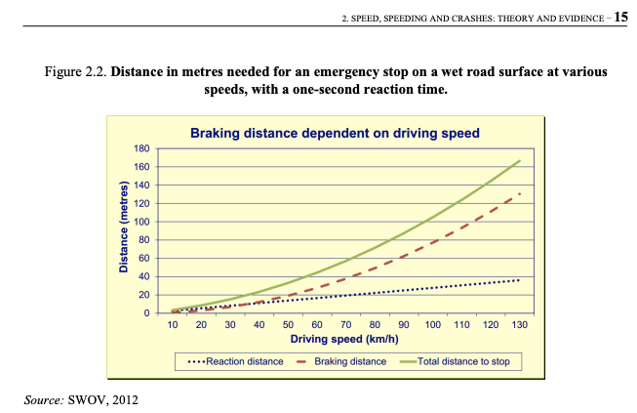

Ask a family member or community member: What are the speed limits in different parts of your community? Have they changed? Should they be changed?

